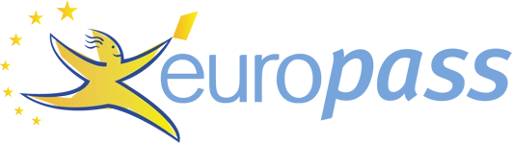
Curriculum vitae

PERSONAL INFORMATION Jetmira Millaku
Rr. Ymer Berisha (Kosovo) +383 44 785 776
jetmiramillaku@gmail.com

WORK EXPERIENCE

01/11/2014–15/05/2018 Counsellor
Day care center"Pema" Peje, Peje (Kosovo)

15/05/2018–Present School psychologist
Elementary school ''Motrat Qiriazi'', Klina (Kosovo)

01/03/2019–01/04/2019 Nursing in context (Psychology and Sociology) Lecturer
AAB College, Prishtina (Kosovo)

09/10/2019–Present Social Psychology Lecturer
AAB College, Gjakova (Kosovo)

EDUCATION AND TRAINING

2010–2014 Bachelor
University of Prishtina ''Hasan Prishtina"- Faculty of Philosophy, Prishtina (Kosovo)

2014–2017 Master- Clinical psychology and health
University of Prishtina ''Hasan Prishtina"- Faculty of Philosophy, Prishtina (Kosovo)

2018–Present PhD Candidate Psychometrics
Ss. Cyril Methodious University in Skopje (North Macedonia), Skopje (North Macedonia)

PERSONAL SKILLS

Mother tongue(s) Albanian

Foreign language(s)
UNDERSTANDING |  | SPEAKING |  | WRITING
Listening | Reading | Spoken interaction | Spoken production

English B2 B2 B2 B2 B2
Levels: A1 and A2: Basic user - B1 and B2: Independent user - C1 and C2: Proficient user Common European Framework of Reference for Languages

10/11/19 © European Union, 2002-2019 | http://europass.cedefop.europa.eu Page 1 / 1

