PERSONAL INFORMATION | Miradije Imeri
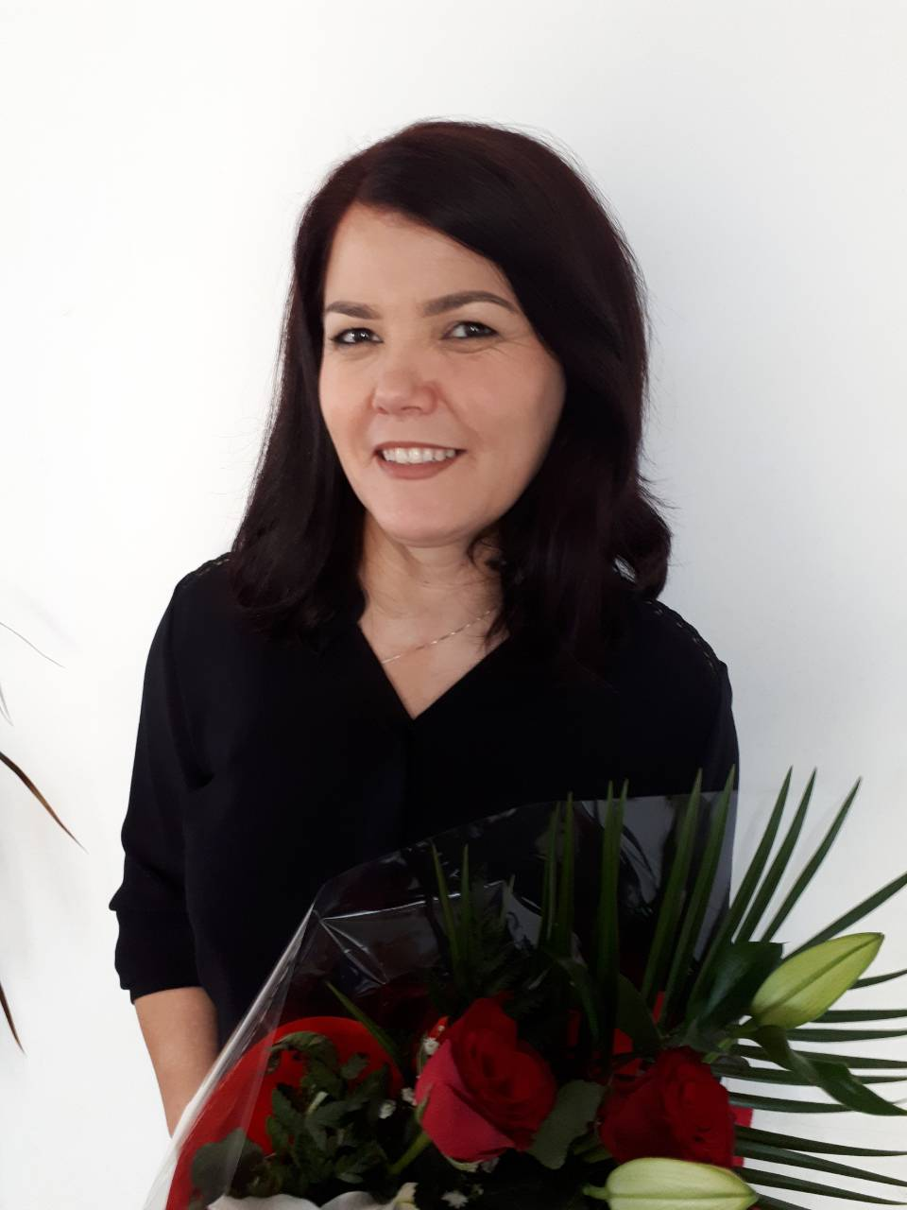 | Prishtinë, 10000 Kosovo
 | +38344581054
 | Miradije.imeri@universitetiaab.com
 | Sex Female| Date of birth 30/09/197g2 | Nationality Kosovare

WORK EXPERIENCE
04/2017 – SINCE | Nurse  Klinika infective- kujdesi intenziv, QKUK, 10000 Prishtinë, Kosovo. http://qkuk.org/  - General nurse  - Patient admission and follow-up by the clinic  - Nursing care for pre-operative, post-operative patients, monitoring of patients' condition, communication with patients, providing therapy according to guidelines and standards.  - Documentation, acceptance, and submission of change.
10/2019 - SINCE | Teaching general nursing
 | AAB university- Industrial zone Prishtine- Fushe Kosove, Kosove. https://aab-edu.net/
- Teaching the subject of “The basic of nursing”
- Testing and evaluating the students
03/2017 - 10/2019 | Teaching Assistant
 | AAB university- Industrial zone Prishtine- Fushe Kosove, Kosove. https://aab-edu.net/
- Teaching asistent the subject of “The basic of nursing" and “Community health care- Home care”
- Monitoring the students in process of testing and exams.

04/2017 - 06/2017 | Research Assistant
 | Heimerer College, Kalbaria; Veranda C dhe D, 10000 Prishtinë, Kosovo. www.kolegji-heimerer.eu
- Collecting data
- Analysing
- Reporting individual results after the analyse

01/2017 - 09/2019 | Nurse
 | KAVAJA hospital, highway Prishtine- Ferizaj, Kosovo. http://www.kavajahospital.com/
- General nurse at surgery clinic
- Patient admission and follow-up by the clinic
- Nursing care for pre-operative, post-operative patients, monitoring of patients' condition, communication with patients, providing therapy according to guidelines and standards.
- Documentation, acceptance, and submission of change.

EDUCATION
10/2015 - 11/2018 | MSc.  Nursing: Education in health care  University of Pristina “Hasan Prishtina”
10/2012 – 07/2015 | BSc.
 | General Nursing
 | Heimerer College

PERSONAL SKILLS

Mother tongue(s) | Albanian
Other language(s) | UNDERSTANDING |  | SPEAKING |  | WRITING
 | Listening | Reading | Spoken interaction | Spoken production
English | B2 | B2 | B2 | B2 | B2

Communication skills | A very good active listener  Clear communication skills  Empathy for others  Humor and lightheartedness  Nonverbal cues and body language  Public speaking and presentation skills  Socializing skills  Excellent verbal and nonverbal communication skills

Organisational / managerial skills | Very organized and punctual with deadlines  Very good at decision making  Very good in team and project managing  Great at team working  Conflict management and resolution skills  Constructive feedback (ways people can improve)  Team building and strong at building trust  Flexibility in thinking and operating style  Networking and building relationships  Tolerance and respect for team members

Job-related skills | - Pedagogical management skills

Digital competence | SELF-ASSESSMENT
 | Information processing | Communication | Content creation | Safety | Problem solving
 | Independent | Independent | Independent | Independent | Independent
 | Levels: Basic user - Independent user - Proficient user
- Good command of office suite (word processor, spread sheet, presentation software)
- Good command of IBM SPSS
- Good command of presentation software like Prezi, Emaze.

Other skills | Writing reports (skills acquired by writing research reports and projects)

Publications  Presentations  Honours and awards | - Sopjani, I., Imeri, M., Vehapi, S,. Gorani, D., Vtoja, S., Tahiri, S., (2016) The relation Between Depressive Symptoms and Self- Care in Patients with Diabetes Mellitus Type 2 in Kosovo. Med Arch. 0350-199x. Prishtine, Kosovo.  - Sopjani, I., Imeri, M., Vehapi, S,. Gorani, D., Vtoja, S., Tahiri, S., (2016) The relation Between Depressive Symptoms and Self- Care in Patients with Diabetes Mellitus Type 2 in Kosovo. ; Sixth International Symposium of Health Sciences 2015, Prishtine, Kosovo  - Imeri. M., Evidence-based nursing care; Nursing week “EVM Infermieror”, 2017. Prishtine- Kosove.  - First place for poster presentation; The relation Between Depressive Symptoms and Self- Care in Patients with Diabetes Mellitus Type 2 in Kosovo ; Sixth International Symposium of Health Sciences 2015, Prishtine, Kosovo

ADDITIONAL INFORMATION

Certifications (Trainings) | - Certificate for attendance of a regular professional meeting – Third meeting of the national societies of nephrology from Kosovo, Macedonia and Albania,2012.  - Certificate of participation in the fourth scientific seminar of hemodialysis physicians and nurses; Fourth Scientific Seminar of Hemodialysis Physicians and Nurses 2011  - Certificate of participation in the training on the subject: Evidence-based nursing care as an active participant. : Nursing Week 2017  - Certificate of completion of training: pediatric trauma care- for nurses primarily in pediatric hospitals 2018  - Certificate of Participation in the Nine Seminar of Dialysis and Nursing Science: Kosovo Dialysis School,2017  - Certificate of participation in the training on: Psychiatric Nursing and Mental Health. ; Faculty of Nursing, Continuing Vocational Education Program "Nursing EVP" 2017.  - Certificate for Presentation of the Thesis: The Impact of Case Management on Nursing Education: AAB Institute, International Health Day - First Symposium. 2017  - Certificate of participation in the training on: Nursing care in intensive care and anesthesia; AAB Institute - Nursing Week 2017  - Certificate of participation in the tenth scientific seminar of dialysis nurses. Kosovar Dialysis School, 2018  - Certificate of attendance in the CME course of Prishtina, 2019.  - Certificate of attendance: AAB Institute, Integrated Approach to Health and Health Education - Second Symposium, 2018  - Certificate of attendance: Qeap- heimerer; Hand Hygiene training for Healthcare Workers ,2016.  - Certificate of attendance: Qeap-Heimerer : Fifth International Symposium of Health Sciences: “Challenges on transferring successful practices to Medical Sciences “ 2014.  - Certificate of attendance of Fourth international Symposium of Health Sciences, “ Toward Improvement of health sciences”, 2013.  - Certificate of attendance of the sixth international symposium of Health Sciences, “Health, Beyond the Borders of Physical Wellbeing”, 2015.

